GridCommons
GridCommons contains the basic grid information which is used for creating the grid data structure (GridData). The information in grid commons is stored for the cells and for each cell it contains a global ID, coordinates of vertices, neighbour cells, type of edges (internal or of various boundary types) and type of the grid simplex (line, triangle, square, etc.). The global ID is a unique ID for each cell corresponding to the grid (read from the grid file). Each time the application is started the global IDs of the cells remains the same but a renumbering of cells is done because the code runs in parallel and communication issues between processors are important. In this renumbering the cells get global indices which are unique among all processors and also local indices which are only valid on the corresponding processor. If the code is running only on one processor then the global and local indices are the same. In figure of the following example, at the left side a grid is shown on which the global IDs of the cells are shown. On the right side the renumbering is done and cell indices are local indices. Inside each cell there are indexing systems for Vertices and edges. Indexing of vertices and cells are not arbitrary.
If we have a self made grid we must provide some information to GridCommons. Information in grid commons is only stored for the cells which belong to the corresponding processor. These are the cells for which computations are done and they are called locally updated cells.

Note:
GridCommons is an abstract class and its constructor must be created using the constructor of a derived class.

Information to be set to the GridCommons

- GlobalID
An array which stores global IDs of cells
  - Index: local cell index in the update-range
  - This ID is unique
  - There is also a reverse mapping from the global IDs to local indices through GlobalId2CellIndexMap.
- Vertices
A 3D array of type double in which the global coordinates of vertices of cells are stored
  - First index: local cell index in the update-range
  - Second index: vertex index in cell
  - Third index: spatial direction
- CellNeighbours
A 2D array that for each cell stores the global IDs of the neighbour cells
- First index: local cell index in the update-range
- Second index: edge index in cell (each neighbour corresponds to one edge of the cell)
  - A negative value stored in this array indicates that the corresponding edge is on boundary of physical domain
- EdgeTags
It is a 2D array which stores the edge tags (numbers assigned to edges) of each cell
  - First index: local cell index in the update-range
  - Second index: edge index in cell
  - Zero is assigned to internal edges (in the interior of computational domain) by default
  - Edges of each boundary type are assigned non zero values (smaller than tags of periodic boundaries which are defined from 181 to 255)
- EdgeTagsNames
It’a dictionary which provides names (strings) correspond to edge tags. The names are set using the Add method of IDictionary class in c# (see the following example).
- m_GridSimplex
It must be set to Line for 1D, Triangle or Square for 2D and Tetra or Cube for 3D grids.
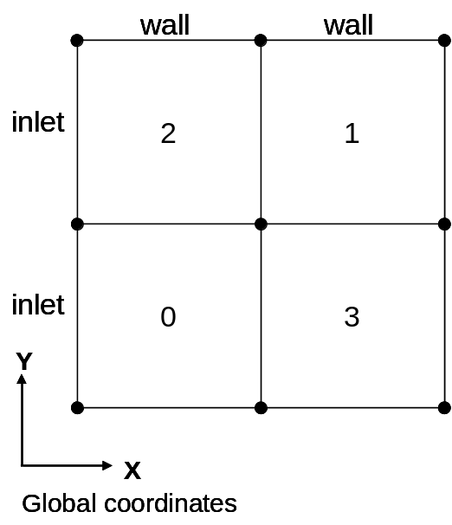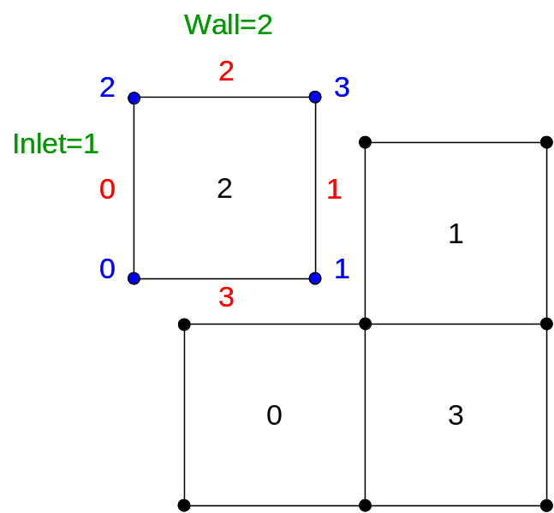
Edge and vertex indexing systems in cells
Grid

GlobalID[0]=2
GlobalID[1]=1
GlobalID[2]=0
GlobalID[3]=3

Vertices[0,0,0]=x coordinate of vertex 0 in global coordinates
Vertices[0,1,0]=x coordinate of vertex 1 in global coordinates
Vertices[0,2,0]=x coordinate of vertex 2 in global coordinates
Vertices[0,3,0]=x coordinate of vertex 3 in global coordinates

Vertices[0,0,1]=y coordinate of vertex 0 in global coordinates
Vertices[0,1,1]=y coordinate of vertex 1 in global coordinates
Vertices[0,2,1]=y coordinate of vertex 2 in global coordinates
Vertices[0,3,1]=y coordinate of vertex 3 in global coordinates

CellNeighbours[2,0]=-123
CellNeighbours[2,1]=1
CellNeighbours[2,2]=-123
CellNeighbours[2,3]=0

EdgeTags[2,0]=1
EdgeTags[2,1]=0
EdgeTags[2,2]=2
EdgeTags[2,3]=0

EdgeTagsNames.Add(1,”inlet”)
EdgeTagsNames.Add(2,”wall”)
m_GridSimplex=new Square()
Cell indexing
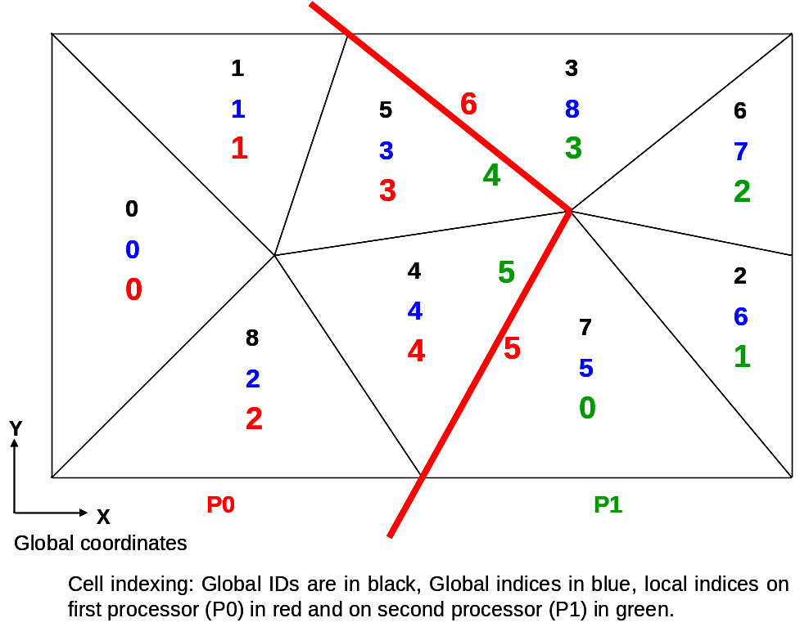

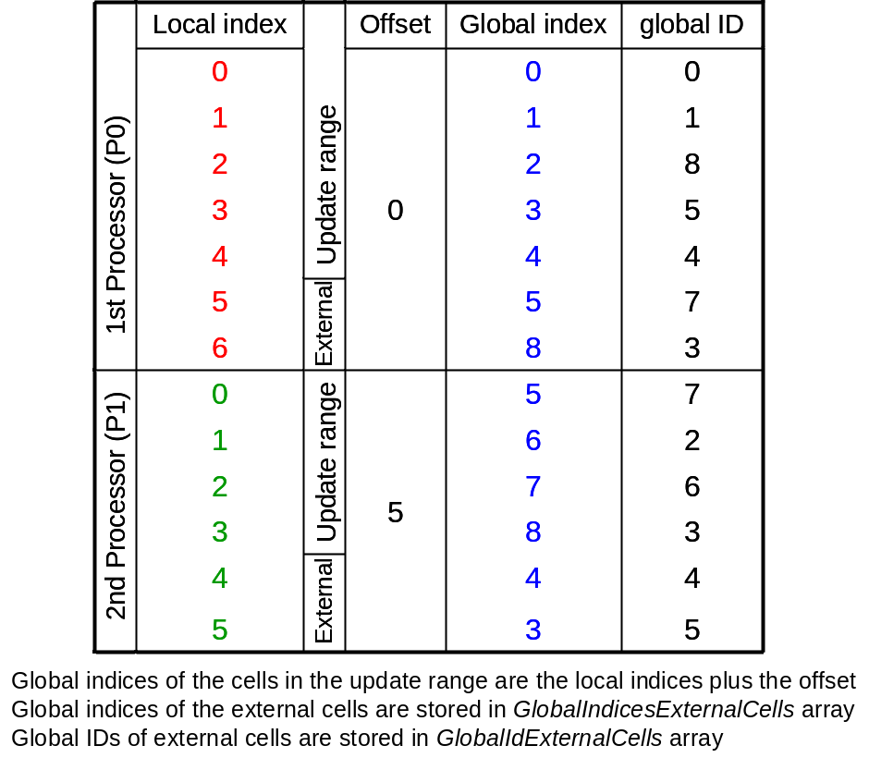
How global indices are assigned?

In the previouse example we had nine cells which have the glonal IDs from 0 to 8. These global IDs are read from the grid file. They are used any time some data (for example the result of our computations) are saved to or loaded from files. In the picture below there is a graph showing connections between neighbouring cells. If we distribute the cells among processors according to their global IDs (shown in gray boxes beside the graph), cells 0 to 4 lie on the first processor (P0) and the rest on the second one (P1). According to the cell graph, during the computations we need to communicate between the two processors 9 times! So a renumbering of cells is necessary.
The software parMETIS is used to redistribute the cells among processors with minimum communication requirements. Indices assigned to cells by this redistribution are the global indices. As a result there would be also a mapping between global indices and IDs. If we don’t use the parMETIS during seting up the BoSSS kernel (see documentation on Context and on Program), there would be no redistribution and the global indices would be the same as global IDs.

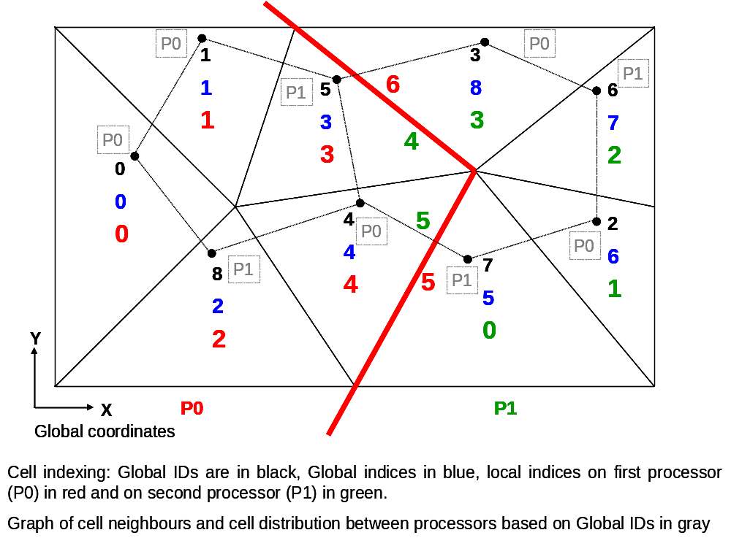
GridData
The grid data is extracted from GridCommons and contains the information that grids must provide. On every processor besides the data corresponding to the locally updated cells (the cells for which calculations are done) there are some data stored from the neighbour cells which belong to other processors. These cells are called external cells. The edges which are handled on each processor belong to the locally updated cells but the vertices belong to both locally updated and external cells. There are no global indices or IDs for vertices and edges so they only have local indices and indices in the cells to which they belong. To distinguish the boundary edges from the others their indices starts from zero to smaller than the NoOfBoundaryEdges. The cells which do not share edges with external cells are called internal cells.

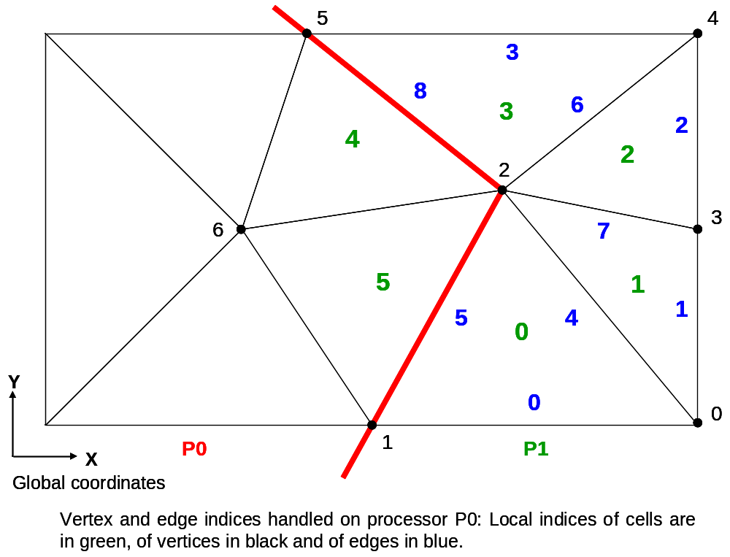

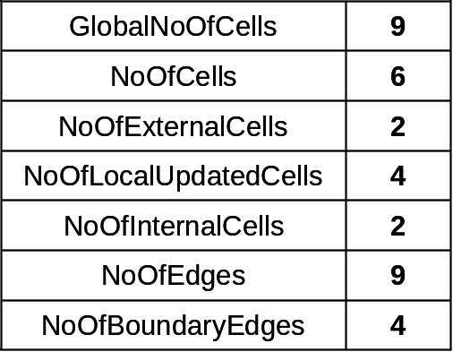

The following information is available in GridData object.

About vertices
- Vertice
It is a 2D array of type double which stores the global coordinates of all vertices/nodes handled on a processor (vertices of the cells in update range and the external cells)
- 1st index: local vertex index
- 2nd index: spatial dimension

About edges
- NoOfEdges
Total number of all edges handled on this processor (edges of cells in the update range)
- NoOfBoundaryEdges
It is the number of edges (on a processor) which lie on boundary of the physical domain. All edges which have index 0 to this value minus one lie on the boundary of the physical domain. These boundary edges are bounded to only one cell. All edges with higher indices are bounded to two cells.
- Edges
It is a 2D array that for each edge stores the local indices of the cells to which it belongs.
  - 1st index: local edge index
  - 2nd index: 0, 1 which means first and second neighbours
  - If a negative cell index is stored it indicates that the edge is a boundary edge.
Example: Let Edges[i,0] = 123 and Edges[i,1] = 321 then the edge i is the common edge of cell 123 and cell 321.
- EdgeIndices
It is a 2D array that stores the indices assigned to each edge in the cells to which it belongs.
- 1st index: local edge index
- 2nd index: 0,1 first and second neighbours
- If edge i is a boundary edge the entry [i,1] would be negative
Example: let Edges[i,0] = 123 and Edges[i,1] = 321 and EdgeIndices[i,0] = 1 and EdgeIndices[i,1] = 1. Then the edge i is the 1st edge of cell 123 and also the 1st edge of cell 321.
- EdgeTags
It is an array which stores the edge tags (numbers assigned to edges)
  - index: local edge index
The same definition as the edge tags for GridCommons
- Normals
It is a 2D array of doubles that stores the normal vector on each edge. The normal vector always points from the first to the second neighbour cell of the edge
- 1st index: local edge index
- 2nd index: spatial component of the vector

About cells
- GlobalNoOfCells
Number of cells in all processors
- NoOfCells
Total number of cells handled on a processor (locally updated plus external cells)
- NoOfExternalCells
This is the number of external cells on a processor. No computations are carried out for these cells, but their values are required.
- NoOfLocalUpdatedCells
Number of locally updated cells, the cells which are computed on this processor (in contrast, see NoOfExternalCells)
- NoOfInternalCells
Number of internal cells, the cells which do not share edges with external cells
- CellVertices
A 2D array of type integer that for each cell stores the local indices of its vertices
- 1st index: local cell index
- 2nd index: vertex index in cell
- GlobalIdExternalCells
This is an array that stores global IDs of external cells. External cells have local indices j in the range NoOfLocalUpdatedCells <= j < NoOfCells.
- Index: local cell index minus NoOfLocalUpdatedCells
- GlobalIndicesExternalCells
This is an array that stores global indices of external cells. External cells have local indices j in the range NoOfLocalUpdatedCells <= j < NoOfCells.
- Index: local cell index minus NoOfLocalUpdatedCells

About Transformations

Related to edges
- InterCellTransformations
An array of type GridData.InterCellTransformation which contains the transformation for each edge
- index: local edge index

- TrafoTo2ndCell
An array of bytes which stores the transformation index (related to inter cell transformation, InterCellTransformations)
- index: local edge index
- AbsDetEdgeTransformation
An array of doubles that are the absolute values of the (Jacobi) determinant of the transformation from the edge coordinate system to the global coordinate system (This transformation is not stored for later use)
  - index: local edge index

Related to cells
- Transformation
A 2D array of doubles which stores the linear part of the affine-linear transformation from the coordinate system of some cell to the global coordinate system, or Jacobi-matrix
  - 1st index: local cell index (locally updated and external cells)
  - 2nd index: index for transformation matrix entry
Let D be the spatial dimension, the DxD - transformation matrix is stored in column major order (FORTRAN order). So in 2D the 2nd index is in the range of 0-3 and in 3D in the range of 0-8
Example (2D): entry (1,1) of the transformation matrix is stored by index 0, (2,1) by index 1, (1,2) by index 2 and (2,2) by index 3
- AbsDetTransformation
An array of doubles which stores the absolut values of the (Jacobi) determinant of the transformation matrices stored in Transformation. This is equal to the volume (in 3D or area in 2D or length in 1D) of the corresponding cell, divided by the volume (area or length) of the simplex in reference space.
  - Index: local cell index
- AffineOffset
Affine part of the affine-linear transformation from the local coordinate system of some cell to the global coordinate system
  - 1st index: local cell index
  - 2nd index: spatial coordinate index: 0,1 for 2D and 0,1,2 for 3D
- InverseTransformation
It is a 2D array of doubles which is the linear part of the affine-linear transformation from the the global coordinate system to the coordinate system of some cell. This is Inverse of Transformation
  - 1st index: local cell index
  - 2nd index: index for transformation matrix entry
- TransformLocal2Global
This method performtrans the coordinate transformation of vertices from the local coordinate system (coordinate system of the reference cell) to the global coordinates. This is done using the transformation matrix stored in Transformation and the AffineOffset.
This transformation can be done for the specified number of cells.
  - LocalVerticesIn of type MultidimensionalArray
This array is the input to the method which stores the coordinates of vertices in the local coordinate system of a cell
    - 1st index: vertex index in cell
    - 2nd index: spatial coordinate index 0 for 1D and 0,1 for 2D and 0,1,2 for 3D
  - Len
It is an integer which is the number of cells for which the coordinate transformation is desired. Therefore the cells in the transformation range have indices 0… Len-1
  - j0
Local cell index of the first cell in transformation range
  - GlobalVerticesOut of type MultidimensionalArray
This array is the output of the method which contains the coordinates of vertices in global coordinates
    - 1st index: index of cell in transformation range. This index is equal to local cell index minus j0
    - 2nd index: vertex index in cell, the same as the first index of the input array
    - 3rd index: spatial coordinate index 0 for 1D and 0,1 for 2D and 0,1,2 for 3D
  - OutArrayOffset
An offset into the first index of GlobalVerticesOut, it can be used if we don’t want that the output stored in this array starts with index 0.

